Recently I faced this wired exception while running my [Java application](http://crunchify.com/category/java-tutorials/) on Linux environment.

Javaa Error Message

|  |
| --- |
| java.lang.UnsupportedClassVersionError: com.crunchify.testClass :  Unsupported major.minor version 51.0      at java.lang.ClassLoader.defineClass1(Native Method)      at java.lang.ClassLoader.defineClassCond(Unknown Source)         ......................................... |

The only difference I noticed in about Java Version. I compiled all code on my laptop with version 7 and Linux had version 6. java.lang.UnsupportedClassVersionError happens because of a higher JDK during compile time and lower [JDK](http://crunchify.com/where-is-java-installed-on-my-mac-osx-system/) during runtime.

**Now how to solve it?**

1. Project -> Properties -> Java Compiler
2. Enable project specific settings.
3. Then select Compiler Compliance Level to 1.6 or 1.5, build and test your app.

[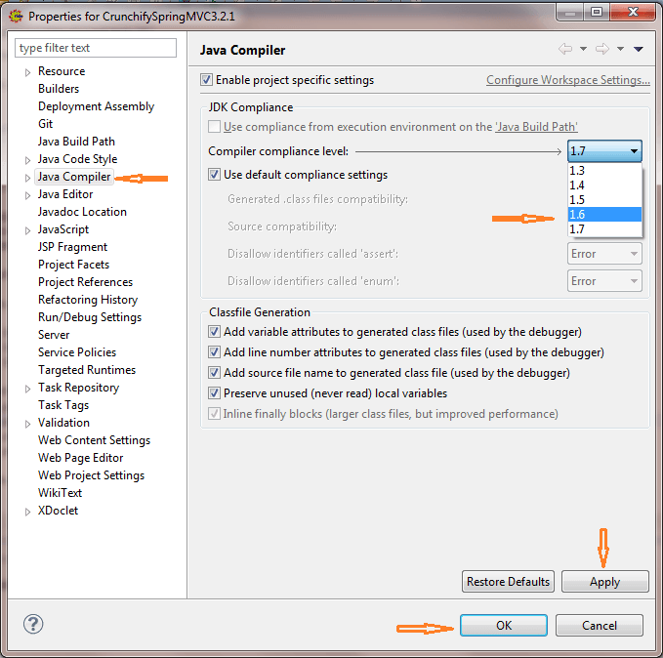](http://cdn.crunchify.com/wp-content/uploads/2014/06/Crunchify-Tips-Fix-Javaa-Compiler-Major-Minor-Version.png)

And that’s all.

Java Version and Versions

|  |
| --- |
| J2SE 8=52,  J2SE 7=51,  J2SE 6.0=50,  J2SE 5.0=49,  JDK 1.4=48,  JDK 1.3=47,  JDK 1.2=46,  JDK 1.1=45 |

The version numbers mentioned above are the version of the JRE the class file is compatible with. There is another way to fix this problem – try bundling your own required JVM with your application and set [**JAVA_HOME**](http://crunchify.com/how-to-setupinstall-maven-classpath-variable-on-windows-7/) from your **startup.sh** script.

**[plain]** [view plain](http://blog.csdn.net/qingfoo/article/details/24714505) [copy](http://blog.csdn.net/qingfoo/article/details/24714505)

1. java.lang.UnsupportedClassVersionError: code/Test : Unsupported major.minor version 51.0
2. at java.lang.ClassLoader.defineClass1(Native Method)
3. at java.lang.ClassLoader.defineClass(Unknown Source)
4. at java.security.SecureClassLoader.defineClass(Unknown Source)
5. at java.net.URLClassLoader.defineClass(Unknown Source)
6. at java.net.URLClassLoader.access$000(Unknown Source)
7. at java.net.URLClassLoader$1.run(Unknown Source)
8. at java.security.AccessController.doPrivileged(Native Method)
9. at java.net.URLClassLoader.findClass(Unknown Source)
10. at java.lang.ClassLoader.loadClass(Unknown Source)
11. at sun.misc.Launcher$AppClassLoader.loadClass(Unknown Source)
12. at java.lang.ClassLoader.loadClass(Unknown Source)
13. at java.lang.ClassLoader.loadClassInternal(Unknown Source)
14. Exception in thread "main"

jdk版本错误，一般出现的原因是用到了高版本的某些特性，在elicpse的ctrl+1下，不小心选择修改编译器的版本所致。

修正方法：右键->Properties->java compiler->Compiler compliance level:修改为你现有所安装的java版本。或者选择升级到合适的jdk版本